Design principles & Patterns
Exercise 1: Implementing the Singleton Pattern

Code:
1. Logger.java

import java.time.LocalDateTime;
public class Logger {

//private instance

private static volatile Logger instance;

//private constructor

private Logger() { }

public static Logger getInstance() {
if (instance == null) {
synchronized (Logger.class) {
if (instance == null) {
instance = new Logger();
}
}
}

return instance;
}

public void log(String message) {
System.out.printf("%s %s%n", LocalDateTime.now(), message);
}
}

- SingletonTest.java

public class SingletonTest {

public static void main(String[] args) {

Logger logger1 = Logger.getInstance();
Logger logger2 = Logger.getInstance();

//Testing the Singleton Implementation

System.out.println("Same instance? " + (logger1 == logger2));

logger1.log("Application started");
logger2.log("Still using the same logger");
}
}
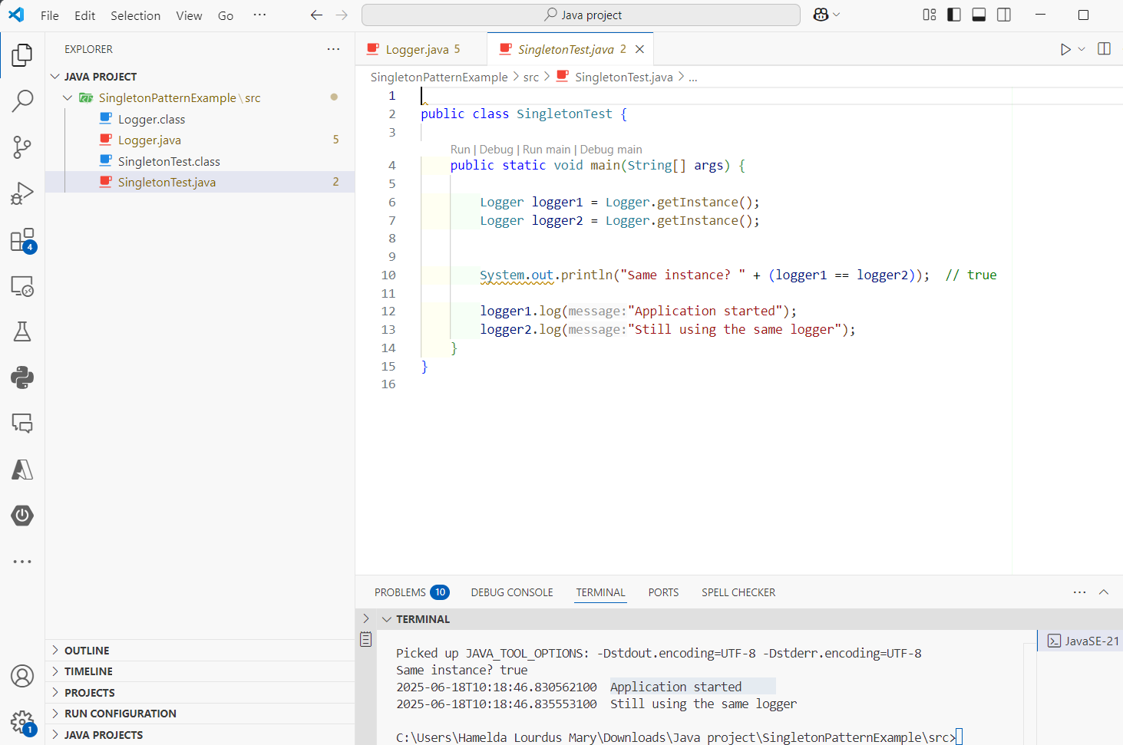

Output:

Same instance? true
2025-06-18T10:18:46.830562100 Application started
2025-06-18T10:18:46.835553100 Still using the same logger

Exercise 2: Implementing the Factory Method Pattern

Code:

- Document interface:

// Document.java
public interface Document {
String getType();
void open();
}

2.Concrete Products

//WordDocument.java

public class WordDocument implements Document {

@Override
public String getType()
{
return "Word";
}

@Override
public void open()
{
System.out.println("Opening a Word document…");
}
}

//PdfDocument.java

public class PdfDocument implements Document {

@Override
public String getType()
{
return "PDF";
}

@Override
public void open()
{
System.out.println("Opening a PDF document…");
}
}

//ExcelDocument.java

public class ExcelDocument implements Document {

@Override
public String getType()
{
return "Excel";
}

@Override
public void open()
{
System.out.println("Opening an Excel spreadsheet…");
}
}

3.Factory pattern

//DocumentFactory.java
public abstract class DocumentFactory {

public abstract Document createDocument();

}

// WordFactory.java

public class WordFactory extends DocumentFactory {

@Override
public Document createDocument()
{
return new WordDocument();
}
}

//PdfFactory.java

public class PdfFactory extends DocumentFactory {

@Override
public Document createDocument()
{
return new PdfDocument();
}
}

//ExcelFactory.java

public class ExcelFactory extends DocumentFactory {

@Override
public Document createDocument()
{
return new ExcelDocument();
}
}

4.Client code

//FactoryDemo.java

public class FactoryDemo {

public static void main(String[] args) {
DocumentFactory wordFactory = new WordFactory();
DocumentFactory pdfFactory = new PdfFactory();
DocumentFactory excelFactory = new ExcelFactory();

Document word = wordFactory.createDocument();
Document pdf = pdfFactory.createDocument();
Document excel = excelFactory.createDocument();

openAndPrint(word);
openAndPrint(pdf);
openAndPrint(excel);
}

private static void openAndPrint(Document doc) {
doc.open();
System.out.println("Type reported by object: " + doc.getType());
System.out.println("---");
}
}
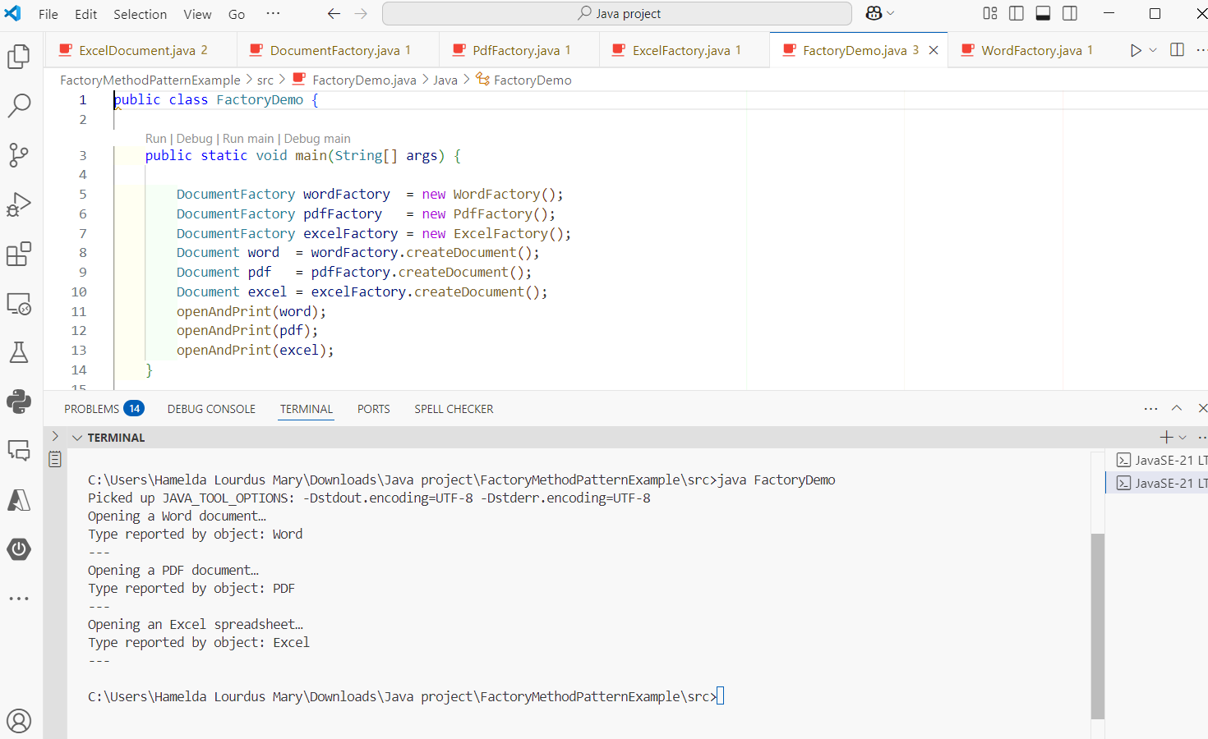

Output:

Opening a Word document…
Type reported by object: Word
---
Opening a PDF document…
Type reported by object: PDF
---
Opening an Excel spreadsheet…
Type reported by object: Excel
---

